**Project Design Phase-II**

**Technology Stack (Architecture & Stack)**

|  |  |
| --- | --- |
| Date | 03 October 2022 |
| Team ID | PNT2022TMID40587 |
| Project Name | IoT Based Safety Gadget for Smart Connectivity for Better Road Safety |
| Maximum Marks | 4 Marks |

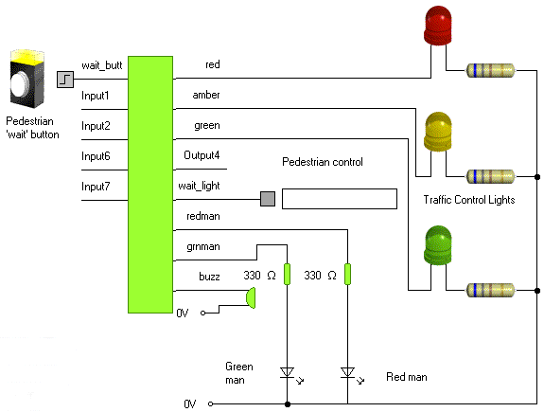

Guidelines:

1. Always wear a seatbelt.
2. Avoid distractions.
3. Do not cross the speed limits.
4. Service your car regularly.
5. Follow traffic signals.
6. Maintain lane discipline.
7. Be careful during bad weather.
8. Maintain a safe distance.

**Table-1 : Components & Technologies:**

|  |  |  |  |
| --- | --- | --- | --- |
| **S.No** | **Component** | **Description** | **Technology** |
|  | User Interface | How user interacts with application Mobile App, | HTML, CSS, JavaScript / Angular Js / React Js etc. |
|  | Application Logic-1 | Logic for a process in the application | Java / Python |
|  | Database | Data Type, Configurations etc. | MySQL, NoSQL, etc. |
|  | Cloud Database | Database Service on Cloud | IBM DB2, IBM |
|  | File Storage | File storage requirements | IBM Block Storage or Other Storage Service or Local Filesystem |
|  | External API-1 | Purpose of External API used in the application | IBM Weather API, etc. |
|  | Infrastructure (Server / Cloud) | Application Deployment on Local System / Cloud  Local Server Configuration:  Cloud Server Configuration : | Local, Cloud Foundry, Kubernetes, etc. |